Sam McDowell

7/15/2020

Lab 5.4

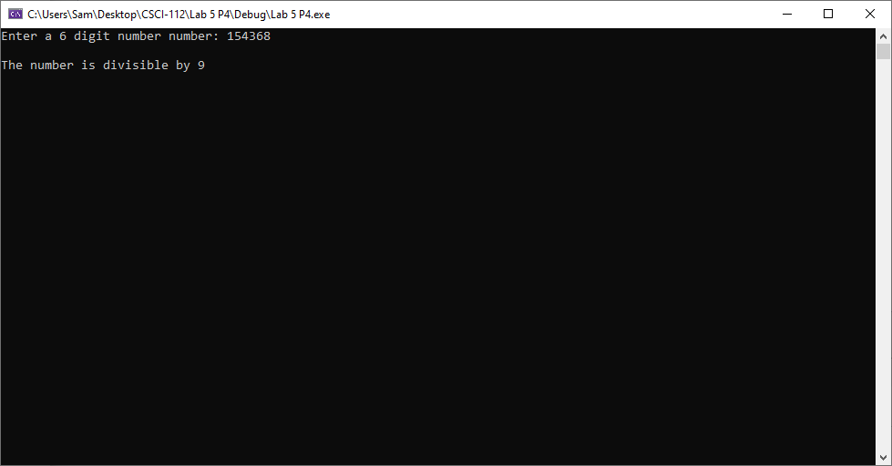

# Transcription:

Enter a 6 digit number number: 154368

The number is divisible by 9